WEEK 1
1.complete the datapath
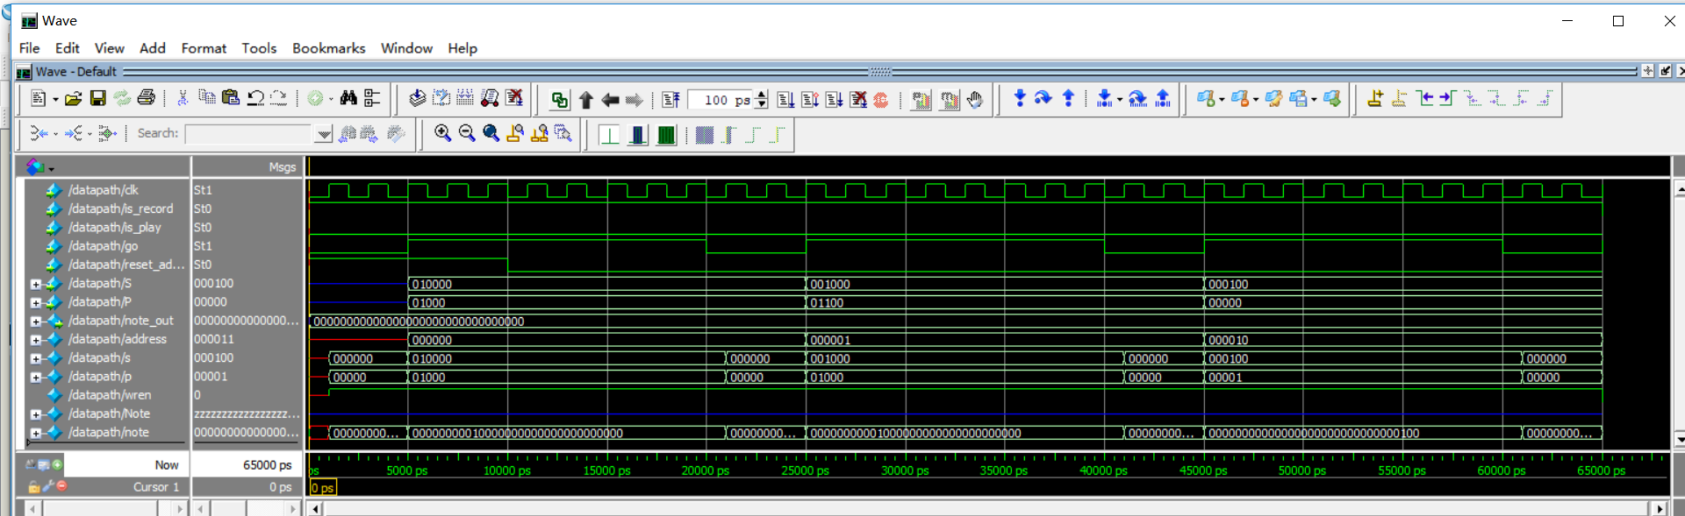
- Main input is_record, is_play, go , reset_address[from control module]
- S[5:0], P[4:0] from the guitar
- Main output, note_out[31:0] (32 kinds of notes)
- Is_record=1 convert S,P to notes and stored to address given
- Is_play=1 read from address given

2.complete data input from guitar
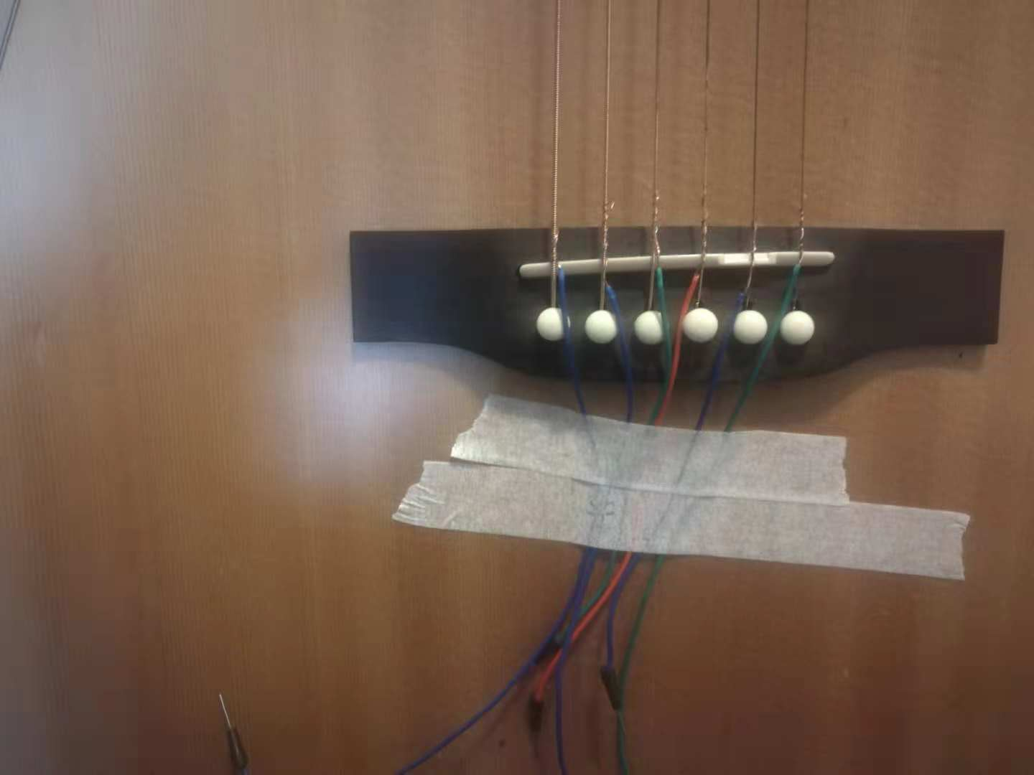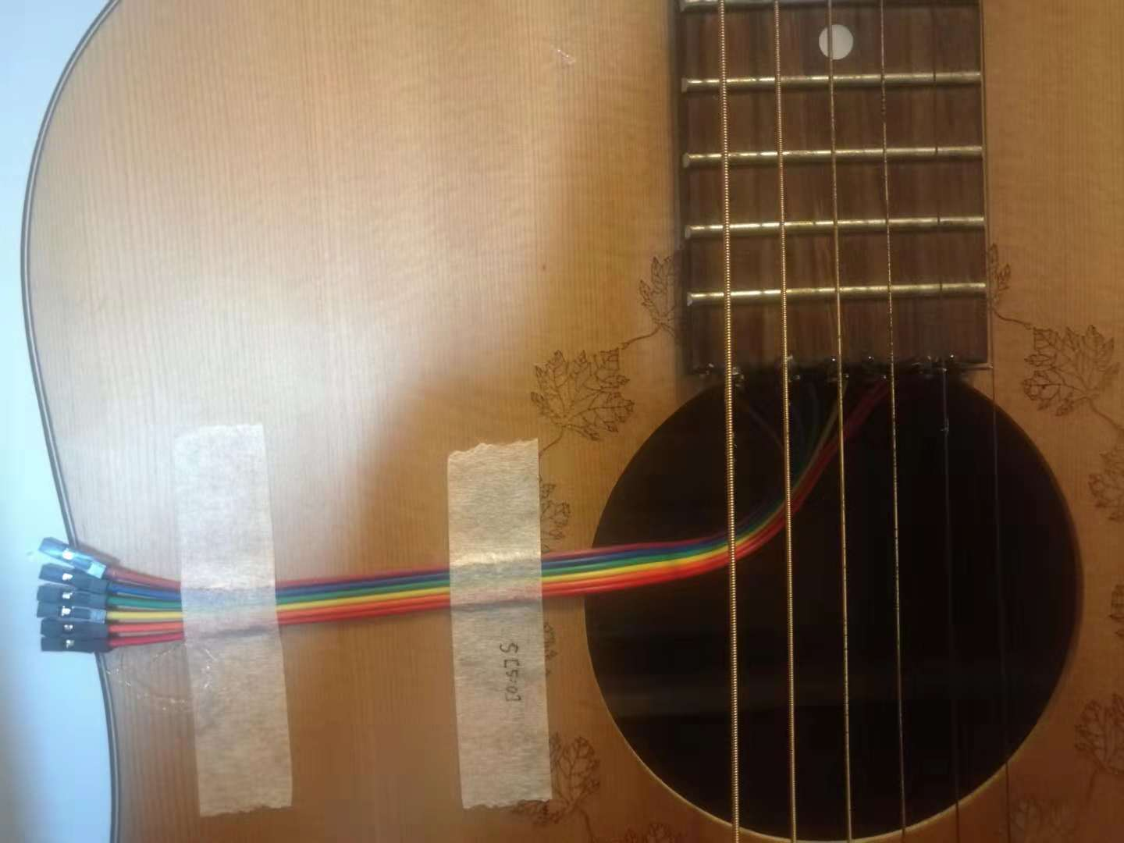
Power source into each cord Input of S[5:0], detect which string is being played
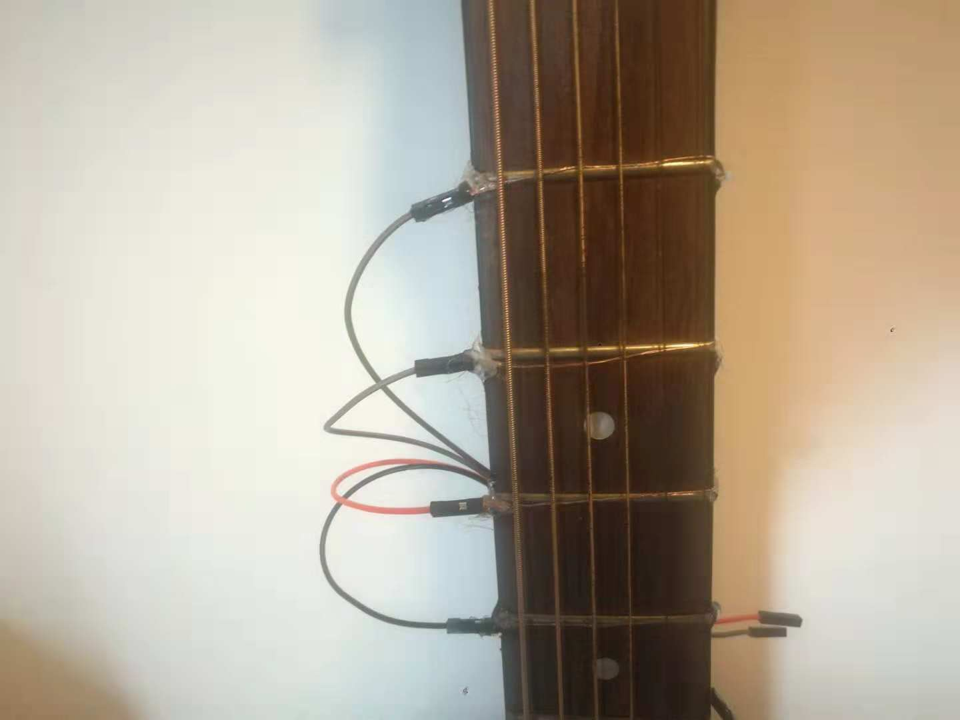
Input of P[4:0], detect which metal bar is pressed

